As the Awesome Artist, your job will be to create a picture of a specialist part of the story. As you read, think about what it might look like if you were making a video or taking a picture with a camera. You should use enough details in your picture so that the other boys and girls can tell exactly which part of the story you illustrated.
Awesome
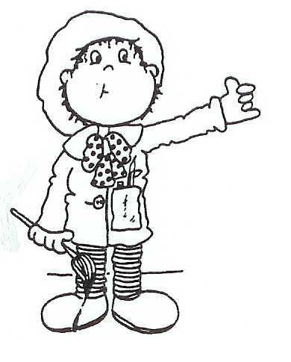
Artist

Literature Circle Bookmarks/Desktop Nametags

