As the Clever Connector, your job will be to make a connection between the book you are reading and your own life. As you read today, ask yourself some questions: Does this part of the story remind you of something that happened to you or someone you know? Have you read another story like this one or does it remind you of a movie that you have seen? Be ready to share your clever connection!
Clever
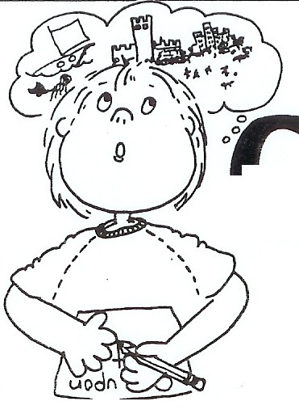
Connector

Literature Circle Bookmarks/Desktop Nametags

