As the Passage Picker, your job will be to find and share a special part of the story. As you read, look for a part of the story that you would like to read aloud to the group. It might be a funny or exciting part. It could be something that is very important to the story, like the problem or the solution. The Passage Picker usually reads a paragraph or one page. Remember to practice reading your part ahead of time.
Passage
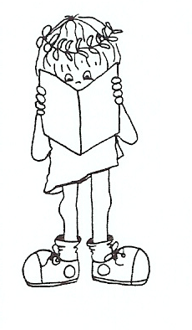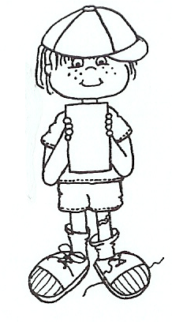
Picker

Literature Circle Bookmarks/Desktop Nametags

