As the Super Summarizer, your job will be to tell the rest of the group what happened in this part of the book. Think about the most important things to talk about. You may want to follow the “First, Next, Then, Finally” plan or the “Who, What, When, Where, Why” format. Please remember that everyone in your group has already read the story, so keep it short!
Super
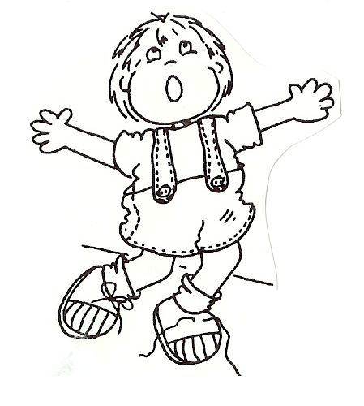
Summarizer

Literature Circle Bookmarks/Desktop Nametags

