As the Word Wonder, your job will be to find special words in this part of the story. As you read, look for words that you don’t understand. Write them down on your sharing sheet, and then find out what they mean after you finish reading. You can ask your mom or dad, or you can look them up in the dictionary or thesaurus. You may also find words that you think are important to the story, like a secret clue in a mystery. Be ready to share the words that you wondered about!
Word
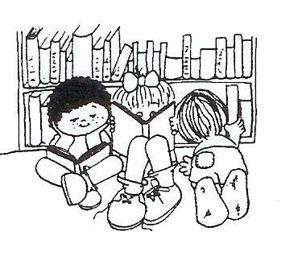
Wonder

Literature Circle Bookmarks/Desktop Nametags

